Title: Optical connection networks

Name: A LEELA KRISHNA REDDY
Reg-no: 12210083
Email-id: lkradhey@gmail.com

Abstract— Optical connection networks have surfaced as a promising result to meet the raising demands of high- speed, low- quiescence, and energy-effective communication systems. This review paper synthesizes the current state- of- the- art technologies, infrastructures, and challenges in optic connection networks. By consulting seminal exploration papers, an overview of the crucial generalities, recent advancements, and implicit directions for unborn exploration. The conversations encompass colorful aspects, including optic switch technologies, network topologies, routing algorithms, and operations in data centers and high- performance computing.
In this paper the work has been implemented on the dataset called “optical_network_connection” and the following models were implemented: Linear regression, Ridge regression, Lasso regression and Elastic net regression. Amongst the many regression models one model outperforms all the rest model and that model is the linear regression model with:
Train Accuracy: 0.80
Test Accuracy: 0.73
R2 Score: 0.73
MSE: 0.01
Keywords— Ridge , Lasso ,Elastic net and Linear regressions , R2 score , MSE(mean squared error)

Introduction
Machine learning is a type of artificial intelligence that gives computers the ability to learn and adapt without being programmed. Neural networks have been around as a form of machine learning since the 1950s. However, in the last decade neural networks have become increasingly important for theoretical problems. This change is due to three main factors: (1) the availability of big data (big data), (2) the increasing use of dedicated processors, including GPUand TPU [2], and (3) advanced machine comparative learning algorithms. These allow estimating the appropriate time [3]. The demand for faster, more efficient, and flexible connectivity in modern computing and communications is increasing. As traditional electronic networks face limitations in terms of bandwidth, power consumption, and latency, the need to manage the increasing amounts of data produced by these technologies (new products such as cloud computing, big data analytics, artificial intelligence, and the Internet of Things) also increases. (IoT). In this context, optical interconnect networks appear to be a promising solution to these challenges. These networks use light to transmit data and offer advantages over traditional electronic networks, such as higher bandwidth capacity, lower latency, lower power consumption and less electromagnetic interference. Therefore, they can change the way data is transferred and processed in computers. Optical interconnect networks have many applications in many fields, from on-chip interconnects to data centre networks and high-performance computer systems. Therefore, it is important to pay close attention to the latest developments in this field, including successes, current challenges, and forward-looking messages. This article aims to provide a comprehensive overview of the connectivity of optical devices, including principles, basic technologies, technological processes, and recent work. By combining information from existing literature and research results, this review aims to uncover the potential of fiber optic connectivity in creating the future of high speed, electrical power, and communications. As the life goes on, all the data acquired is in humongous amounts of bytes to compute the data into machine learning models we would require large bandwidth data cables which uses less energy and high efficiency transfers that is where we see the optical interconnection networks play a major role in the existing industry. We see that systems now require high-bandwidth connections to servers and compute nodes, right down to the board and chip module. [1] At the same time, to increase the efficiency and utilization of resources, supercomputers and data centers are seeking new models at every level of the network, from the entire system to the chip module. Energy-efficient, resilient, and elastic data transfer networks for which silicon photonics are well suited.

Literature review
Sangeetha Rengachary Gopalan [4] used 4 models which includes KNN Algorithm, svm decision tree and have used deep learning to predict faults in optical networks with a 95% accuracy rate and reduce their frequency getting the following results:

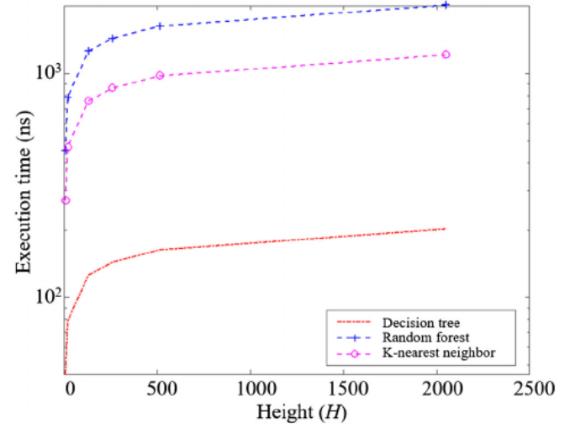

[5] the SVM classification methods are investigated for different QAM. The experimental setup of QAM-DMT optical interconnection system is illustrated in Fig. 9. An arbitrary waveform generator (AWG) is used to generate the DMT signal with 54 GSa/s. The laser operates at 1550 nm followed with external modulation by a Mach–Zehnder-Modulator.

Cen Wang[6] compare the performance of two CNNs, one is with 3 convolutional layers and 3 pooling layers the classification accuracy of the traffic matrix can arrive to 96.8%, and when testing, the accuracy can keep at 88.1%.

Qiuyan Yao[7] used the following machine learning algorithms to fetch their own records
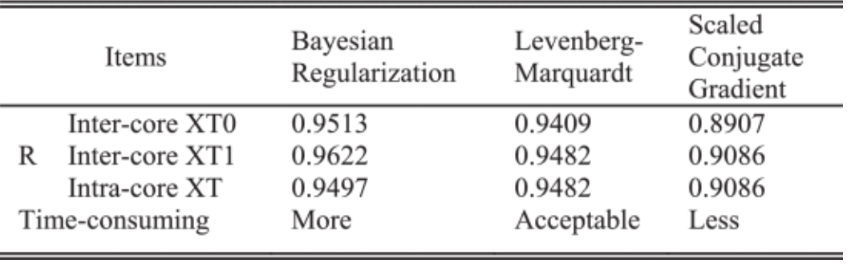

[8] This paper presents 80% target as a reference. Decision tree method is the most accurate, which is superior to the other three methods, and the accuracy of each flow type exceeds 90%.
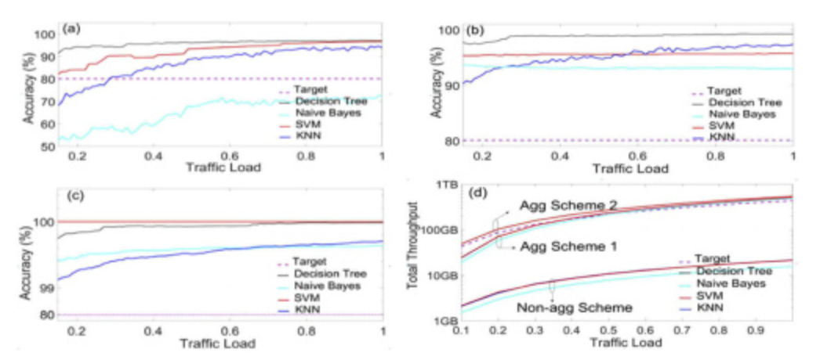
[9] prediction accuracy of the MTIFLN is over 85% even for the 72 hours prediction task. In addition, it has low MAE, MRE, and RMSE values, which are much better than the other three compared algorithms. The results are as follows :

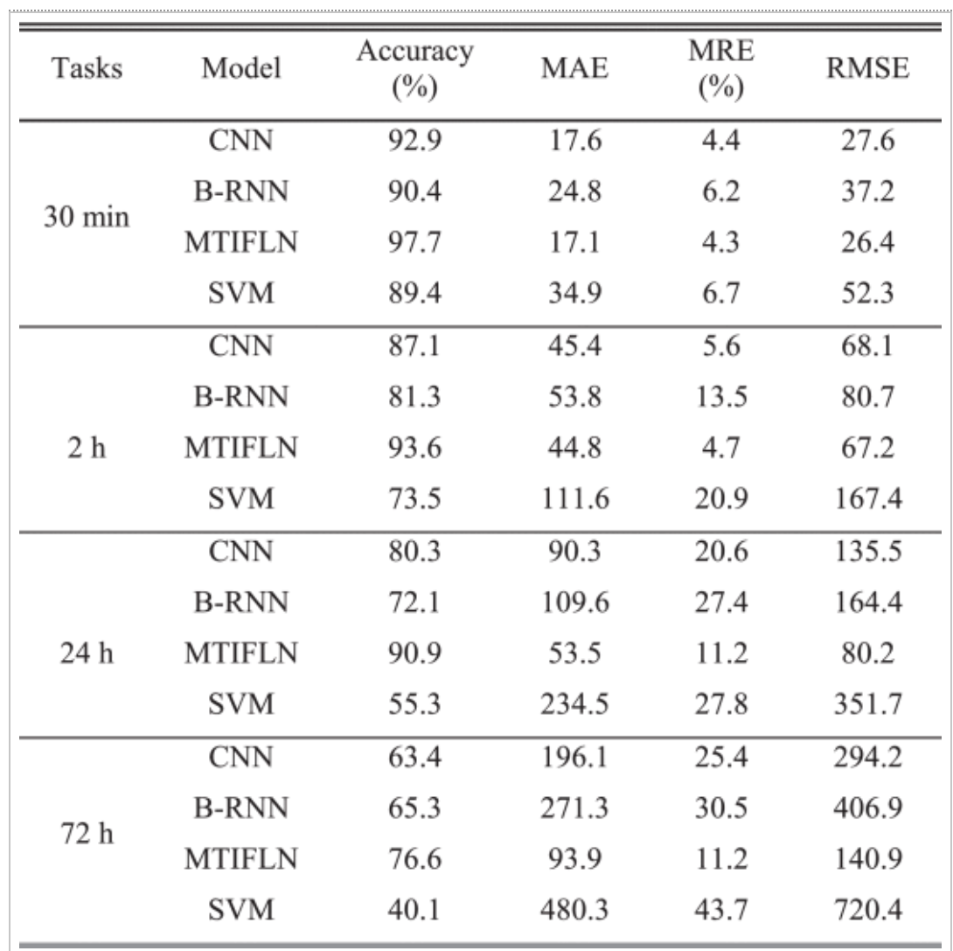

Proposed methodology

Dataset Description

The dataset used for the research was gathered from the UC Irvine machine learning repository, named: optical_interconnection_network.csv . which includes 640 instances and 9 columns.
These are the names of the attributes presented in a column manner : 'Node Number', 'Thread Number', 'Spatial Distribution', 'Temporal Distribution', 'T/R', 'Processor Utilization ', 'Channel Waiting Time', 'Input Waiting Time', 'Network Response Time', 'Channel Utilization'.
1. Node Number: node number represents a unique number present for the each node in the optical network connection.
2. Thread Count: this attribute represents the number of threads or the amount of concurrent tasks/processes getting executed in the network.
3. Spatial Distribution: how the data has been distributed in different number of paths.
4. Temporal Distribution: the type of the network being used in the connecting network.
5. T/R: stands for transmit/receive indicates the flow or communication of the network.
6. Processor Utilization: as the name suggest till what extent the processor was involved in the communication of the network.
7. Channel Waiting Time: this attribute specifies the amount of time a packet or signal waits or waits in the queue before being sent to the network channel for communication. It measures how congested or slow your network is in the connections.
8. Input waiting Time: the time taken for the process to initiate after giving the input.
9. Network Response Time: the time taken for the network to work on the given input.
10. Channel Utilization: represent the active usage of the sending data and signals over the network.
Table 1: Description of the atrtributes

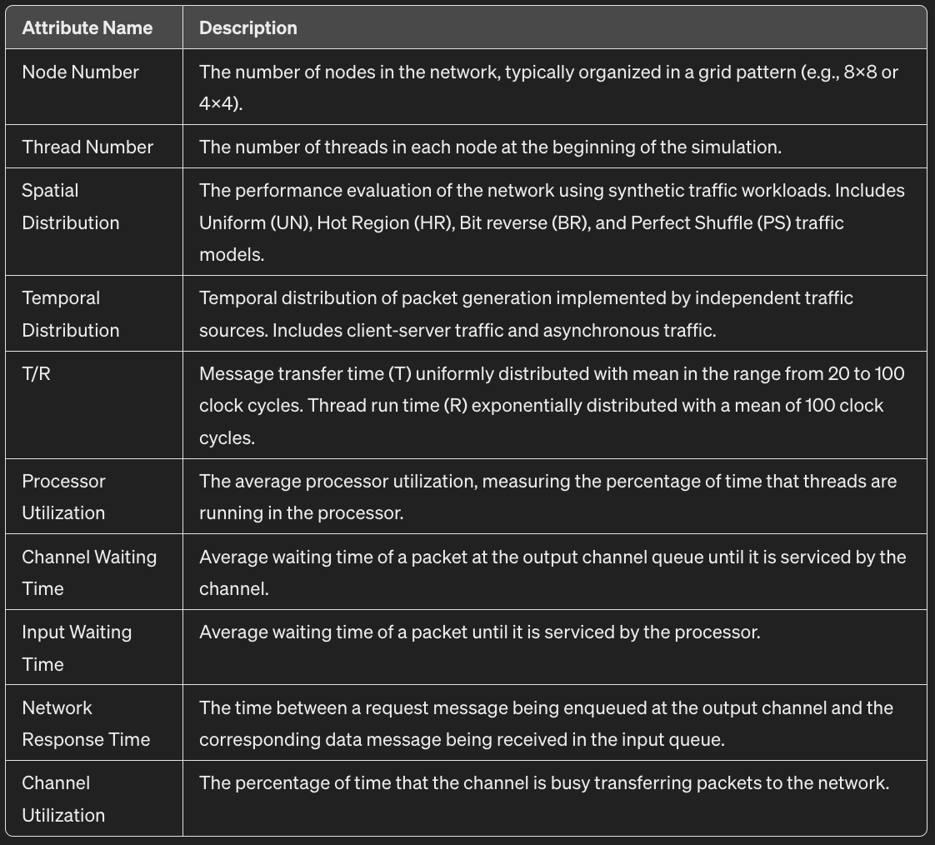

Heat map visualisation
Deployed the seaborn library to visualize the dataset using an heatmap format where the correlation between the different variables is seen by utilizing the colour gradient for the indication of the strength and direction of the correlation.
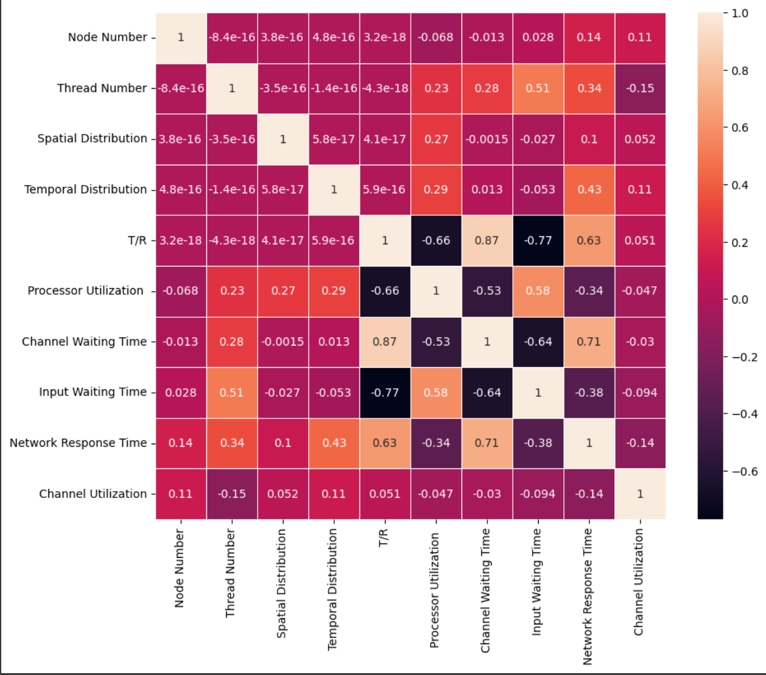

Data Preprocessing and Feature Scaling

When it comes data preprocessing the first taken was of dropping the columns which contained the nul values which were column [10,11,12,13 and 14]. Then the second step includes implementation of the label encoder from the sklearn.preprocessing method LabelEncoder to change the categorical data into the numerical format to fit the data into the model. It was specifically implemented on the columns [‘spatial distribution and temporal distribution’]. Further more used the standard scaler to standardised the data. Lastly, more implemented the train test split for the after usage of the regression models on the data.

Table 2: No. of missing values per feature
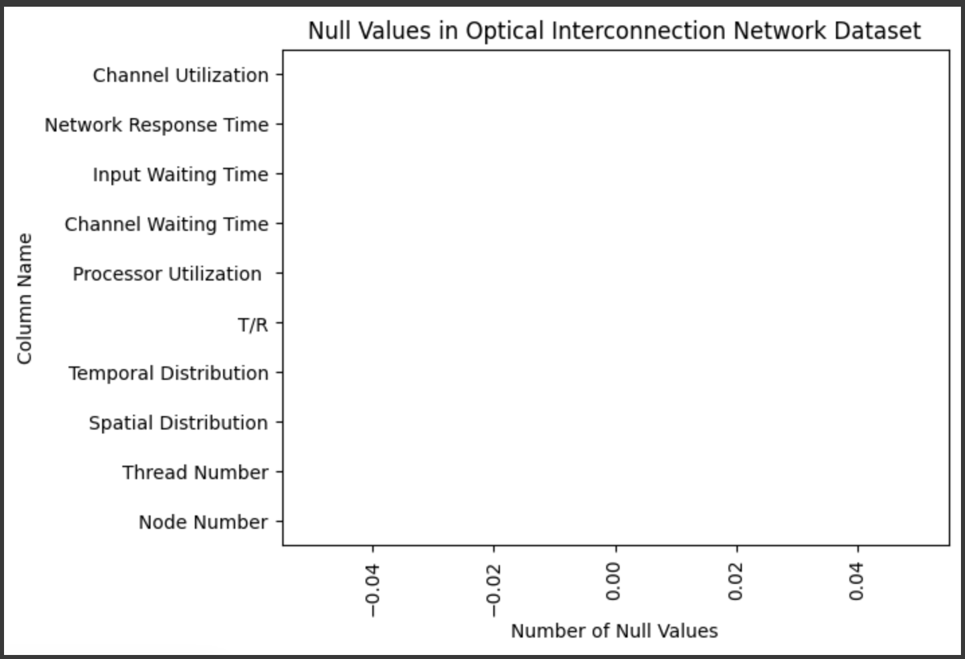

Model training
Now the implementation of the three regression models on the preprocessed dataset.

- Linear regression: basic and commonly used regression model for the predictive analysis, tells the relationship between the dependent and the independent variable.

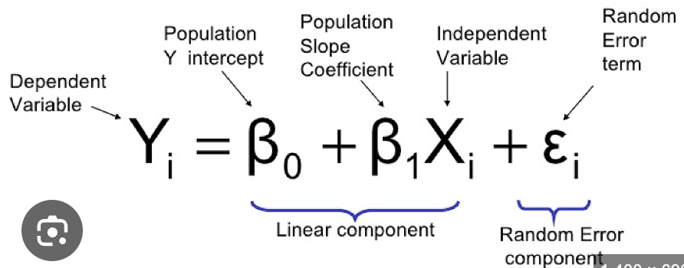

- Ridge regression: is one of a regularization for linear regression models. Regularization a method to reduce the error caused by the overfitting on training data.

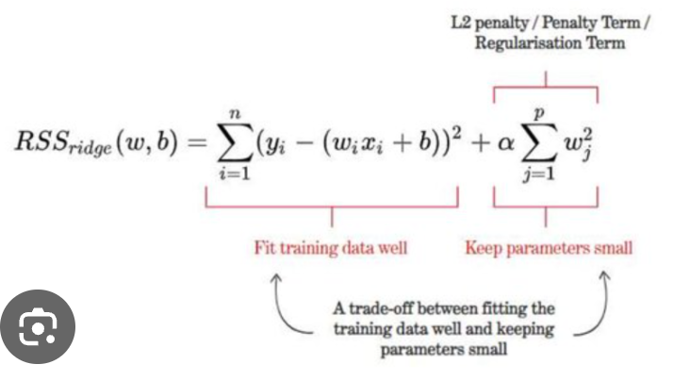

- Lasso regression (Least Absolute Shrinkage and Selection Operator): is another regularization technique which not only helps in reducing overfitting, it can also help in feature selection of data.

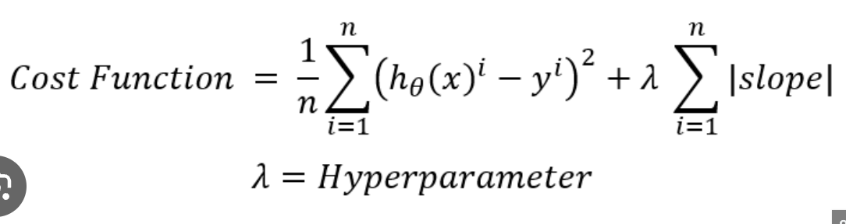

- Elastic Net regression: combines the penalties of both ridge and lasso regressions. Mostly useful when there are multiple features correlated with each other.

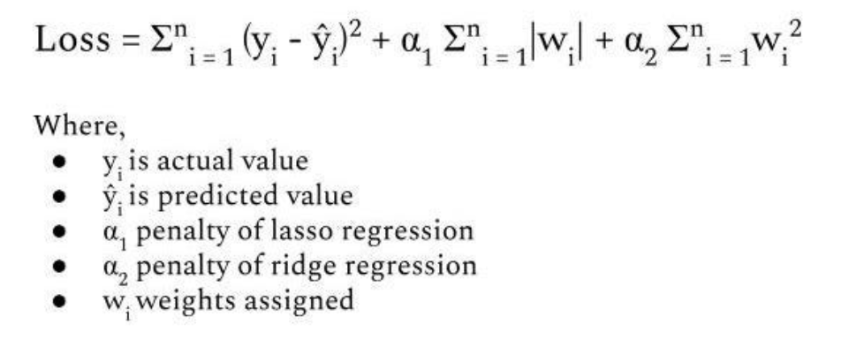

Experimental Analysis
these results provide the assessment of the effectiveness of the different machine learning regression models in predicting optical interconnection network dataset score. Thereafter can be used for analysis of the best model to train the data. After fetching the initial scores, then performed hyperparameter tuning to obtain the below values.

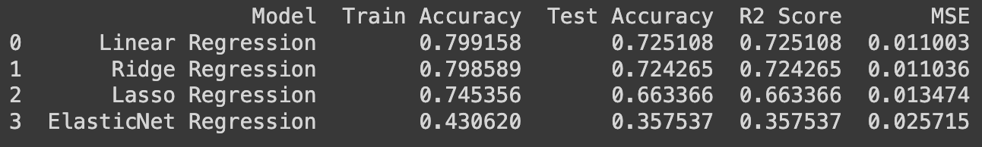

With help of the statistical data, the prediction can be done as linear Regression stands on top with the best accuracy, regression score and with the least error.
The visual representation of the test score from pie chart:

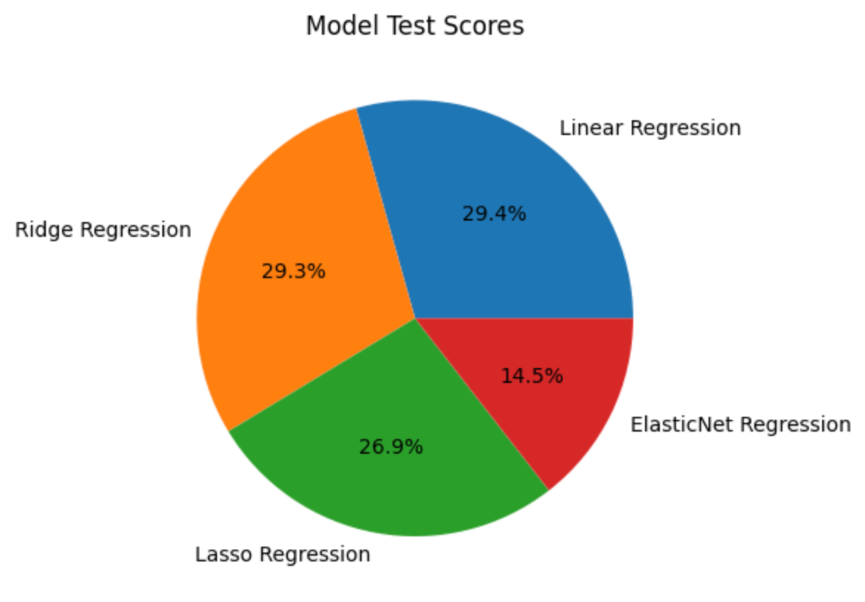

The scatter plot with the line of best fit:

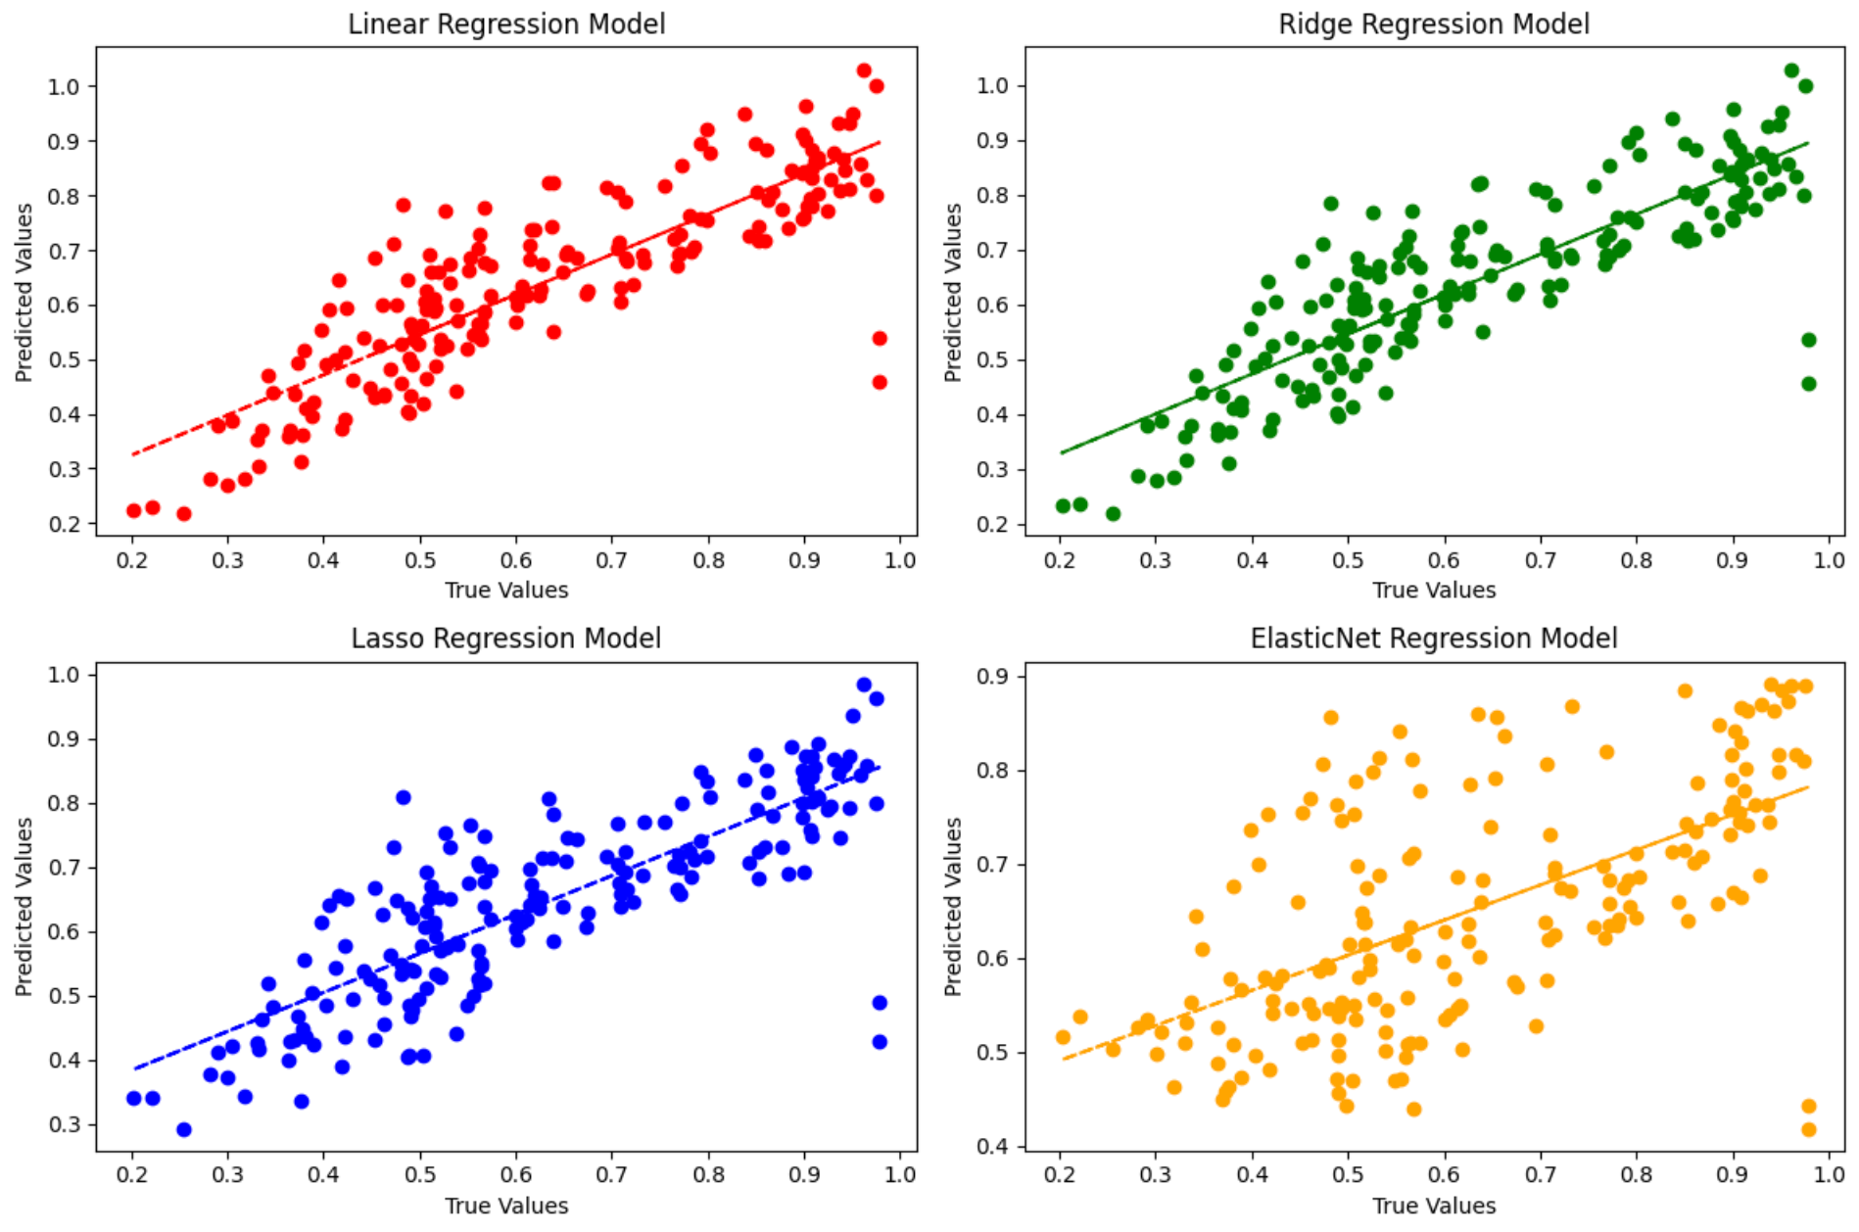

With the help of the upper plots, the prediction can be done stating that linear and ridge regression do outperform the lasso and elastic net and even amongst the ridge and linear regression the linear regression performed the best.

Conclusion and future scope
This study investigated upon the effectiveness of machine learning regression models for predicting the accuracy and performance score for the optical interconnection networks dataset, the focused models were Linear, Ridge, Lasso and Elastic Net regressions.

As per the results the Linear Regression outperforms every other regression model used, this indicates that the use of linear regression can be utilized for the training of the dataset.

While the other regression models showed fair number of capabilities but not as much as the linear regression. More exploration of the hyperparameters for these models can be considered for the future studies.

The ability to predict the best optical network can easily be done with the help of this study to implement in the complex computing technologies.

The future research can add additional upcoming technologies for the topologies for the connection and better dataset including larger instances to make it even more efficient.

References
[1] Q. Cheng, M. Bahadori, M. Glick, S. Rumley, K. Bergman, Recent advances in optical technologies for data centers: a review, Optica 5 (2018) 1354 1370.

[2] N.P. Jouppi, C. Young, N. Patil, D. Patterson, G. Agrawal, R. Bajwa, et al., In-datacenter performance analysis of a tensor processing unit, in: Computer Architecture (ISCA), 2017 ACM/IEEE 44th Annual International Symposium on, EEE, 2017.
[3] K. Hazelwood, S. Bird, D. Brooks, S. Chintala, U. Diril, D. Dzhulgakov, et al., Applied machine learning at facebook: a datacenter infrastructure perspective, in: High Performance Computer Architecture (HPCA), 2018 IEEE International Symposium on, IEEE, 2018.
[4] Sangeetha Rengachary Gopalan, Hemanth Chandran, Nithin Vijayan, Vikas Yadav, Shivam Mishra
First published: 10 January 2023

[5] Chang Wang, Jiangbing Du, Guoyao Chen, Haoyang Wang, Lin Sun, Ke Xu, Bo Liu, Zuyuan He,
QAM classification methods by SVM machine learning for improved optical interconnection, Optics Communications, Volume 444,2019, Pages 1-8, ISSN 0030-4018

[6] Cen Wang; Hongxiang Guo; Xiong Gao; Yanhu Chen; Yinan Tang; Jian Wu; publisher: IEEE 28 February 2019; Electronic ISSN: 2169-3536; DOI: 10.1109/ACCESS.2019.2902166

[7] Qiuyan Yao; Hui Yang; Ruijie Zhu; Ao Yu; Wei Bai; Yuanlong Tan; Jie Zhang; Date of Publication: 06 March 2018; Electronic ISSN: 2169-3536; DOI: 10.1109/ACCESS.2018.2811724

[8] Li Zhao and and Peng Shi, "Machine Learning assisted aggregation schemes for optical cross-connect in hybrid electrical/optical data center networks," OSA Continuum 3, 2573-2590 (2020)

[9] A. Yu et al., "Long-Term Traffic Scheduling Based on Stacked Bidirectional Recurrent Neural Networks in Inter-Datacenter Optical Networks," in IEEE Access, vol. 7, pp. 182296-182308, 2019, doi: 10.1109/ACCESS.2019.2959303.

IEEE conference templates contain guidance text for composing and formatting conference papers. Please ensure that all template text is removed from your conference paper prior to submission to the conference. Failure to remove template text from your paper may result in your paper not being published.

